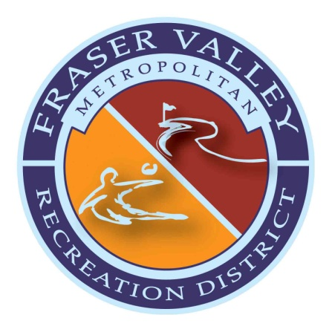

BOARD OF DIRECTORS MEETING AGENDA - AMENDED
Tuesday, April 4, 2023, 5:30pm
Grand Park Community Recreation Center

I. CALL TO ORDER

- ROLL CALL/DECLARATION OF QUORUM/CONFLICT DISCLOSURE

- REVIEW AND APPROVAL OF MINUTES
  - February 28, 2023 Meeting Minutes

- OPEN FORUM
The Board provides opportunity for the public to comment on items not on the agenda.

- ACTION ITEMS
  - RESOLUTION 04.04.23.01 – Colorado Surplus Asset Fund Trust (CSAFE)

- DEPARTMENT REPORTS
  - Financial Report - February 2023
  - Pole Creek Golf Club
  - Grand Park Community Recreation Center
  - Recreation Programming
  - Fraser Valley Sports Complex & IceBox Ice Rink
  - Facilities Maintenance
  - District Administration

- EXECUTIVE SESSION
C.R.S. 24-6-402(4)a – For the purpose of a purchase, acquisition, lease, transfer, or sale of any real, personal or property interest related to the purchase option available through the lease agreement with the owners of the Foundry Cinema and Bowl.

- ADJOURNMENT

________________________________________________________________________________
Join Meeting Via Zoom:
https://us02web.zoom.us/j/7271087488

Dial in:
+1 346 248 7799
Meeting ID: 727 108 7488
________________________________________________________________________________

FVMRD Mission:
Our mission is to provide recreational experiences for our residents and guests through innovative, quality programs and facilities that promote health and wellness.

