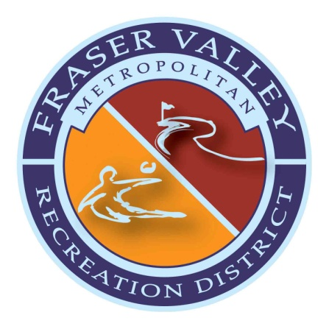
Notice of
Fraser Valley Metropolitan Recreation District
Fiscal Year 2020 Budget Hearings

Notice is hereby given that the following budget hearings for 2020 have been set for the Fraser Valley Metropolitan Recreation District.

The budget hearings will take place as part of the regularly scheduled monthly Board of Directors meetings as follows:

October 22, 2019 – 5:30 pm
Grand Park Community Recreation Center

November 19, 2019 – 2:00 pm
The Foundry Cinema and Bowl

December 10, 2019 – 5:30
Grand Park Community Recreation Center

Any interested elector of the Fraser Valley Metropolitan Recreation District may inspect the proposed budget and file or register any objections thereto at any time prior to the final adoption of the budget.

FVMRD Mission:
Our mission is to provide recreational experiences for our residents and guests through innovative, quality programs and facilities that promote health and wellness.

